Mastering Spring Profiles & Environment Configuration
This topic explains how one Spring Boot application safely runs in multiple environments without code changes.

Why does profiling exist?
Real projects have multiple environments:
Environment | Purpose
DEV | Local development
QA | Testing
PROD | Live users
Each environment needs different:
• DB credentials
• URLs
• Ports
• Timeouts
Hardcoding them is dangerous Profiles allow environment-specific behavior using configuration, not code.

How Spring Executes Profiles Internally?
Startup flow:
- SpringApplication.run()
- Spring builds Environment
- Reads spring.profiles.active
- Loads:
- Profile file overrides default values
- IoC Container is built using final merged config

Example — DBConnection Component
Component
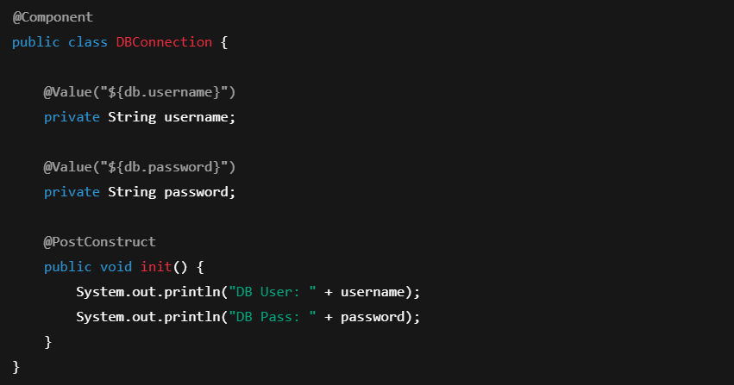
Profile Property Files
application.properties
application-dev.properties
application-qa.properties
application-prod.properties


Runtime Behavior
Active Profile | Loaded Values
dev | dev_user / dev_pass
qa | qa_user / qa_pass
prod | prod_user / prod_pass

Missing Profile File Case
application.properties
If application-prod.properties missing:
Spring falls back to:
This prevents startup failure.
Externalizing Profile Selection
Command line
Maven profile
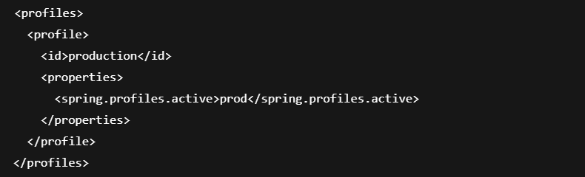Run:

@Profile for Conditional Bean Creation
MySQL Bean
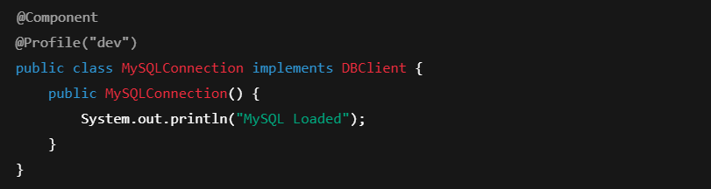NoSQL Bean
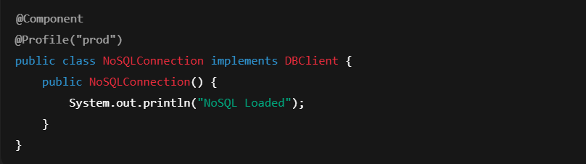
Injection

Behaviour Matrix
Active Profile | Bean Created
dev | MySQLConnection
prod | NoSQLConnection
qa | ❌ No Bean → Crash

Fix:

Multiple Active Profiles
Spring uses last matching property override, but Beans from both profiles can load.
This can cause conflicts.

Difference between @Profile and @ConditionalOnProperty
Feature | @Profile | @ConditionalOnProperty
Based on | Environment | Config value
Level | Bean activation | Feature toggling
Typical use | DEV vs PROD | Feature ON/OFF

Hidden Traps
• Missing profile → startup failure
• Multiple profiles → duplicate Beans
• @Profile ignored in tests without config
• Prod secrets accidentally committed
One-Page Mental Model
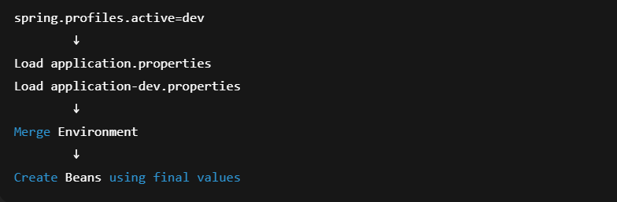
Enterprise Relevance
Profiles are used in:
• Kubernetes deployments
• CI/CD pipelines
• Multi-region systems

Summary - Story
You write one Spring Boot application.
You create:
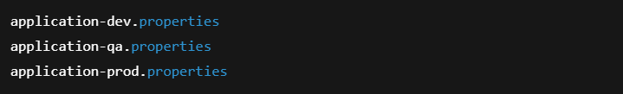At startup:
Spring reads:
Spring builds Environment:
• Loads base config
• Loads prod config
• Overrides values
Then IoC Container is created using PROD values.
Same codebase.
Different runtime personality.
That is environment-driven architecture.

Core Definitions
Term | Meaning
Profile | Named environment (dev, qa, prod)
application.properties | Default config
application-dev.properties | Dev-specific config
spring.profiles.active | Tells Spring which profile to use
@Profile | Creates Beans only for a profile
Environment | Merged runtime configuration store

Interview-Grade Questions on Spring Profiles (Senior Level)
1. How does Spring internally resolve property conflicts when multiple profiles are active?
Spring builds a single Environment object by merging multiple PropertySources.
Order of precedence:
- Command line args
- OS environment variables
- application-{profile}.properties (last profile wins)
- application.properties
When multiple profiles are active:
Spring loads:
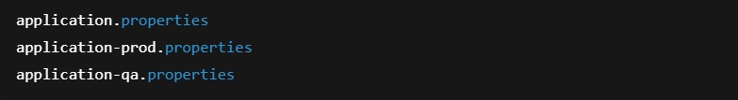If the same key exists in all three:
db.url
Final value = from qa file (last profile).
This is because Spring processes profiles in order and later PropertySources override earlier ones.

2. Why does Spring load both application.properties and application-prod.properties instead of only the profile file?
Spring treats application.properties as the base configuration layer and profile files as delta overrides.
This allows:
• Shared config in base file
• Environment-specific overrides in profile files
Without this, every profile file would need full duplication of all properties.
This layered merge model is core to Spring’s configuration system.
3. What happens if two Beans of the same type are loaded through different profiles?
If both profiles are active simultaneously:
And both contain:
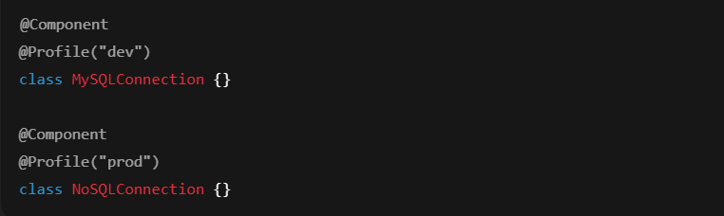Both Beans are registered.
Injecting:
causes:
Because profile selection does not imply exclusivity unless you activate only one profile.
Profiles control creation, not resolution.

4. Why do enterprises avoid hardcoding spring.profiles.active inside application.properties?
Expected Answer:
Because it couples runtime behavior to the artifact.
Real deployments require:
• Same JAR in DEV, QA, PROD
• Environment decides behavior
Hardcoding breaks:
• Docker portability
• Kubernetes deployments
• CI/CD pipelines
Correct approach:
Externalize via:
or environment variables.

5. At what exact point in Spring Boot startup are profiles applied?
Profiles are applied before Bean creation.
Order:
- SpringApplication.run()
- Create Environment
- Resolve active profiles
- Load property sources
- Merge properties
- Build ApplicationContext
- Create Beans using final Environment
Therefore profiles affect:
• Auto-configuration
• Bean creation
• Conditional annotations
Profiles operate at bootstrap phase, not runtime phase.

6. Why can profile misconfiguration cause production outages?
Because:
• Wrong DB credentials
• Wrong message brokers
• Wrong security configs

If:
in production:
• Dev DB accessed
• Test APIs called
• Security disabled
Profiles directly control infrastructure wiring, not just values.

7. Why is @Profile more dangerous than @ConditionalOnProperty in large systems?
@Profile is coarse-grained:
• Entire Bean existence depends on profile
@ConditionalOnProperty is fine-grained:
• Feature toggles independent of environment
Misusing @Profile can accidentally remove critical Beans when profiles change.

8. Why does @Profile not work in some tests?
Because test context may not activate profiles.
Without:
@ActiveProfiles("test")
Spring loads only default profile.
Result:
Beans disappear unexpectedly.

9. Can profiles change at runtime without restart?
No.
Profiles are resolved during bootstrap.
Changing profile requires:
• Context restart
• Pod restart
• Container redeploy
Profiles are startup-time wiring controls, not runtime flags.

10. How do profiles influence auto-configuration classes?
Expected Answer:
Auto-config classes are conditional on Environment.
Example:
Profile determines which auto-configurations are even evaluated.
Profiles therefore indirectly control:
• DataSource creation
• Security config
• Cache config
They influence the framework itself, not just application code.

11. Difference between profile-based and property-based configuration in microservices?
Expected Answer:
Profile | Property
Controls environment | Controls features
Coarse-grained | Fine-grained
Startup wiring | Runtime behavior
Few values | Many toggles
Modern systems use:
Profiles → environment separation
Properties → feature flags

12. Why is Spring Environment considered a first-class abstraction?
Because every major subsystem reads from Environment:
• Auto-config
• @Value
• @Conditional
• Security
• Web server
Environment is the central configuration brain of Spring Boot.
Profiles simply modify that brain.

13. What is the architectural mistake juniors make with profiles?
Expected Answer:
They treat profiles as:
  - “Only for DB URLs.”
In reality profiles control:
• Bean graphs
• Infrastructure wiring
• Security layers
Profiles are architecture-level switches, not just config files.

14. How does profile selection affect Kubernetes deployments?
Kubernetes injects:
SPRING_PROFILES_ACTIVE=prod
Container image remains same.
Only environment variable changes behavior.
This is why Spring Boot is cloud-native friendly.

15. Explain profiles in one architecture sentence.
“Spring Profiles allow the same application artifact to assemble different internal architectures at startup based on environment.”

